1. **• Install Power BI Desktop and share the final screenshot of the report view page which appears when power desktop starts**

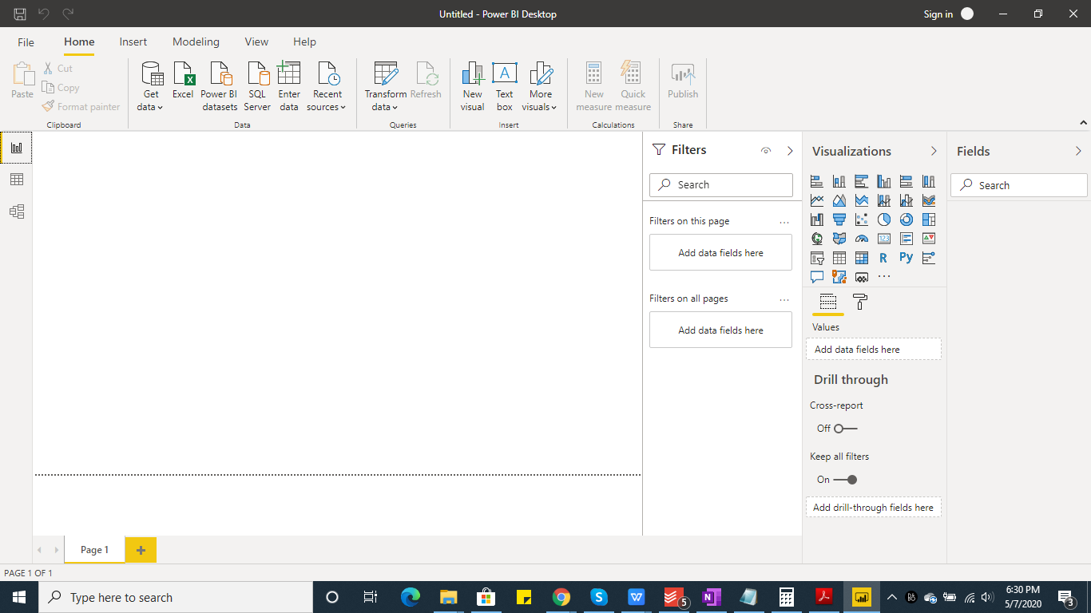

1. **• Prepare a document and with the following screenshot**

* Report View − This is the first screen which appears when Power BI desktop application is opened.
  + - Once the source data is transformed and loaded into the application, we use the Report view section to create various visualizations (reports/dashboards)that help in answering the Business questions.
    - Depending upon the type of analysis required, various chart visualizations are used and configured according to the requirements.

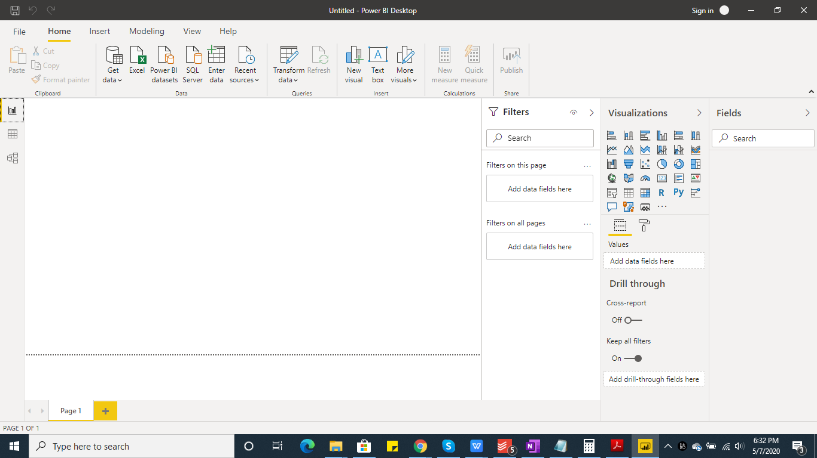

* Data View − This is the screen where data from all the tables loaded into the application can be viewed.
  + - “Fields” section On the right hand side displays the list of tables and all the columns available in each table.
    - We can add new tables,columns and measures here by selecting the table.

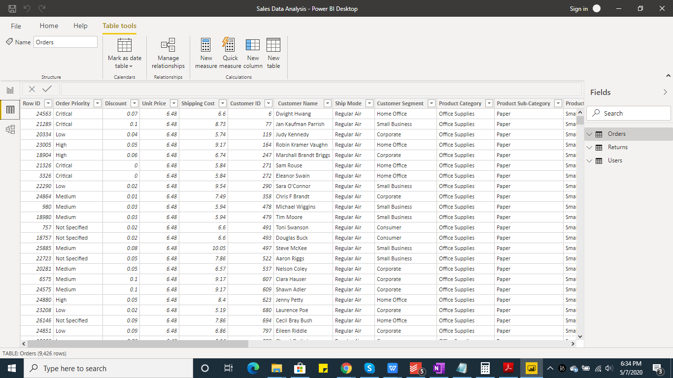

* Model View − In this Data model view screen, we can view the loaded tables and their relationships.
  + - We can manage(edit/add/delete) the table relationships based on the given business data analysis.

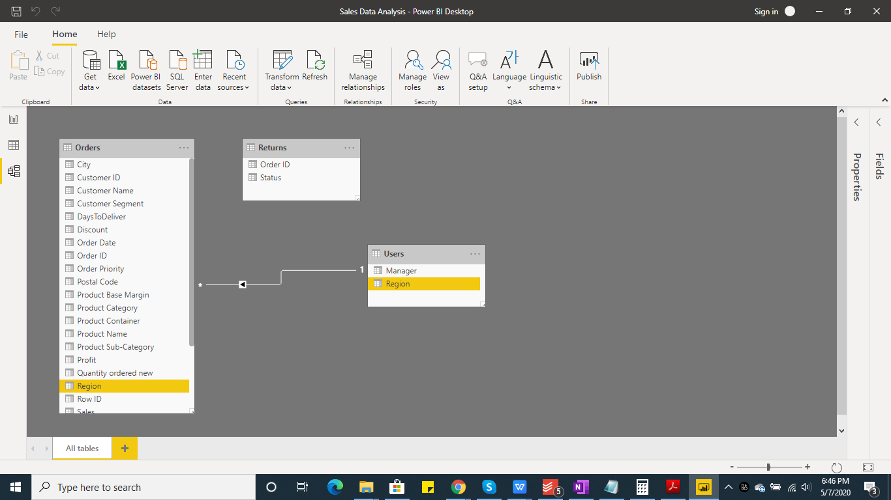

* Power Query Editor − Power Query Editor opens in a separate window.
  + - In Power Query Editor, we have various options to perform data transformation and load the transformed model.
    - On the right hand side, we can see all the transformation steps applied on each table. We can undo the applied steps from bottom.

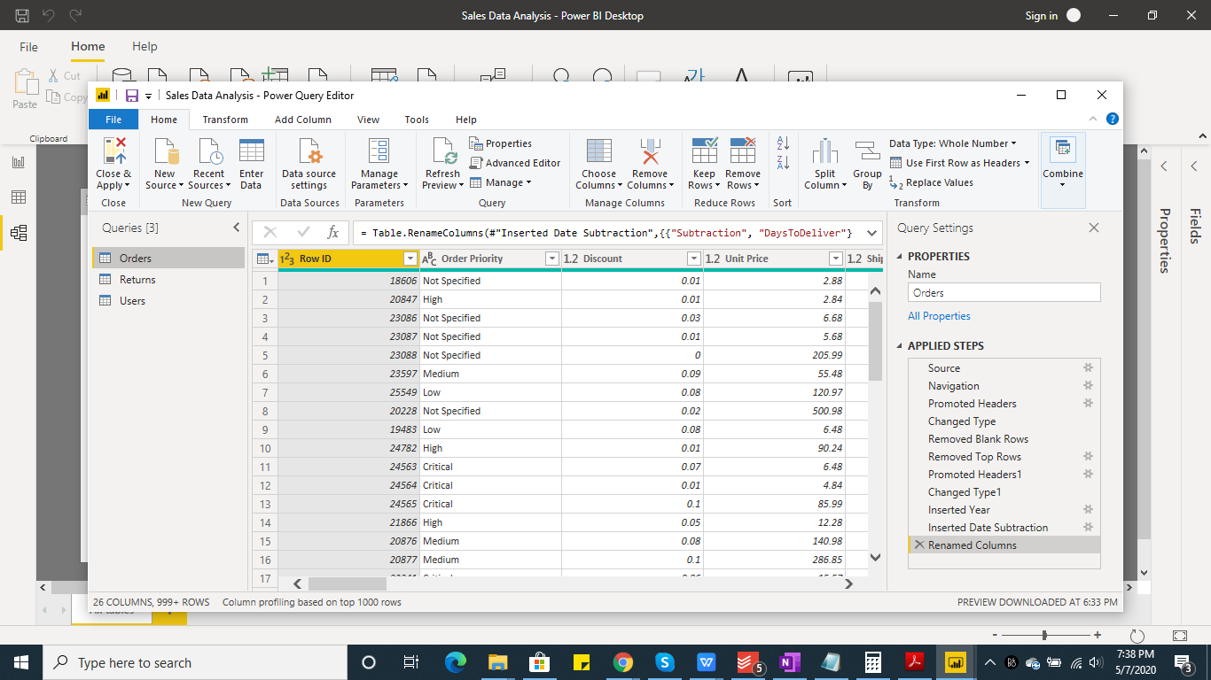

* Advance Editor - In Advance editor, we can view and edit the queries that are executed for data transformation steps.The query is written in M-language (Power query language).

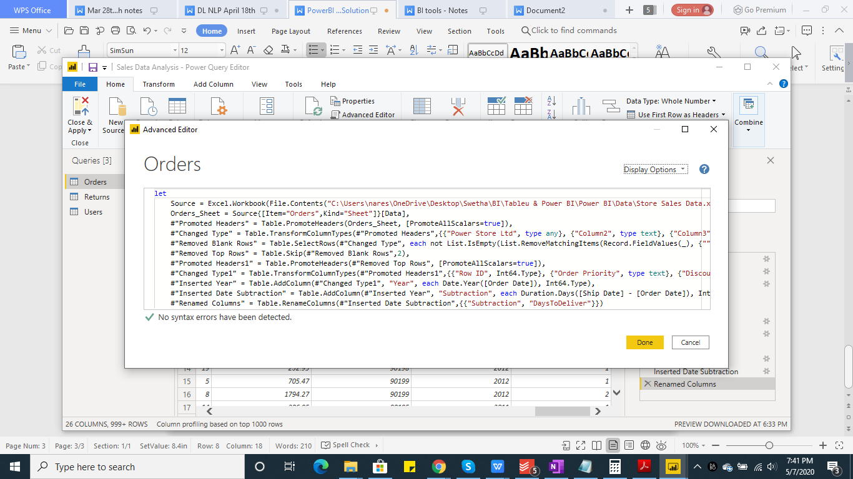

1. **Prepare a document with details of the following along with their price**

* ***Power BI Desktop*** − It is a **free** BI reporting application that can be installed on a desktop. Data from various sources can be loaded and combined into a data model which helps to build visuals reports. The reports can be shared with people in the organization using the Power BI service.
* ***Power BI Pro*** − It is an **individual user license** which helps to view and interact with the reports that are developed and published to the power BI service by others. Pro users can collaborate with other Pro users and share the content between them.Pro license costs about **$9.99/user/month**.It includes data collaboration, data governance, building dashboards with a 360-degree real-time view and the ability to publish reports anywhere. Users can try it a free trial for 60 days before purchasing the subscription
* ***Power BI Premium*** - This is mostly useful for large organizations. While Power BI Pro is an individual license, Premium is an **enterprise BI platform for everyone in an organization**. Premium offers dedicated capacity to deliver more consistent performance and support larger data volumes in Power BI.The Premium plan **starts at $4,995/month** per dedicated cloud compute and storage resource